Giphy Usage Manual

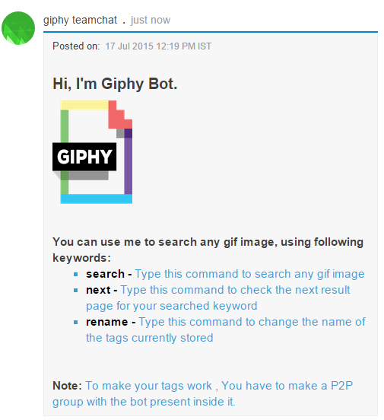
The “help” keyword is used to initiate the bot and list of keywords and some instruction are displayed.

To Search images of different genres type the keyword “search” which opens a form where you can type any genre ad submit. The bot will give you 5 gif images at a time which can be tagged and stored in database for further use. To view more images of same genre user can use the “next” keyword which displays the next 5 images. User can maximum tag 5 images and store it in a database. If the bot is added in the same room and tagged keyword is typed the bot will display the image corresponding to that particular tag.

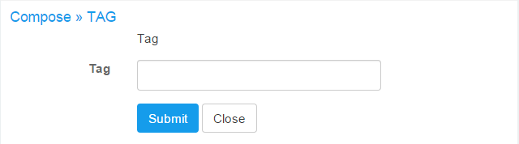

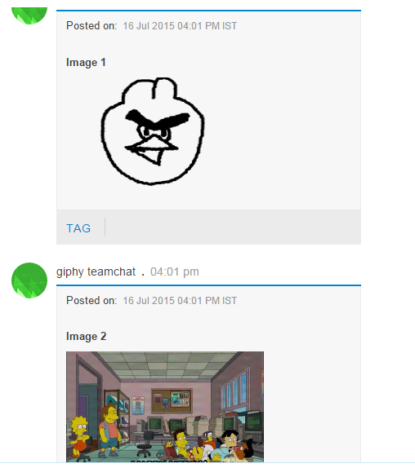

User can add maximum 5 tags and if he tries to tag the 6th tag the following message is displayed

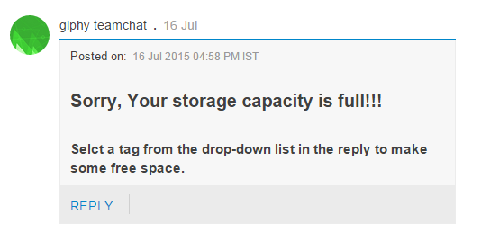

If the user still wants to add he can replace with the any of the stored tags
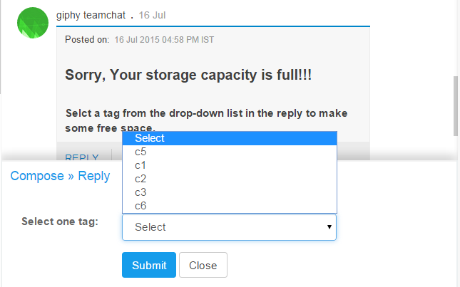

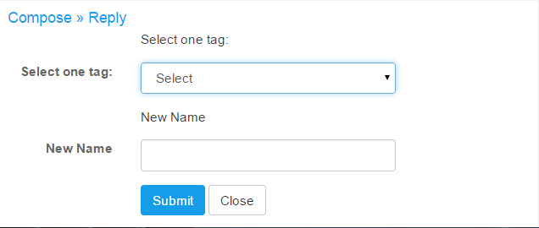
If the user wants to rename any of his tags he can use the keyword rename which gives user the form from which he can select any of the image and rename it
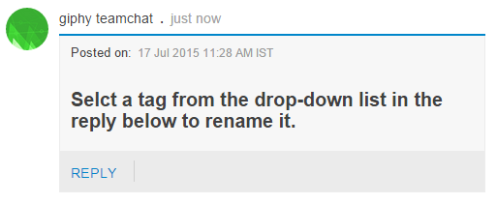

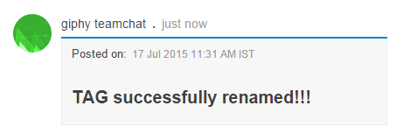

Same Tag cannot be given to any image I.e the tag previouslystored in the database while renaming

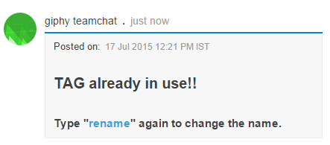

If you give a tag to any picture which is already in use the current image replaces the existing image with the same tag

